**Unikl Telecomunication Club**

Comitee member

**OPKIM Unikl**

Literature Guidance Program Rumah Anak Yatim

**MARA Inovation Competition**

Automatic Temperature and Humidity Contol in Mushroom House (Bronze)











**CONTACT ME**

**REFERENCE**





**EDUCATION HISTORY**

+6017 559 3724

syafiqbakar281@gmail.com

No 281 Persiaran Venice Sutera 7, Desa Manjung Raya, 32200 Lumut, Perak





**Mrs Siti Zaiummi bt Zawawi**

*(Final Year Project Supervisor, UniklBmi)*

Phone :+6013-371 6034











Creative Idea

Communication

Leadership

Meticulous

Independence

**Internship**

**Tumpat Solution SdnBhd**

[Vlan tagged for CELCOM Link]

[Splicing Fibre for CELCOM cable]

**Teknik Janakuasa Sdn Bhd**

[Maintanace for electronic and electrical equipment]

**Work**

**BME Sdn Bhd**

Laborer

**PERSONAL SKILL**

**CO-CURRICULUR ACTIVITIES**

**EXPERIENCE**

Name Mohammad Amirul Syafiq Bin Abu Bakar

Nationality Malaysian

Born Perak, Malaysia

Languages Malay, English

D.O.B 9th July 1991

**BA.OF ENG.TECH IN DATA COMMUNICATION.**

CGPA : 3.02 I SEPT – DEC 2016

UniKL British Malaysian Institute

**DIPLOMA IN ELECTRONIC ENGINEERING**

CGPA : 3.17 I 2010-2013

KKTM Beranang, Selangor

**SIJIL PELAJARAN MALAYSIA**

2009

SMK Batu 10, Perak

**PERSONAL INFO**

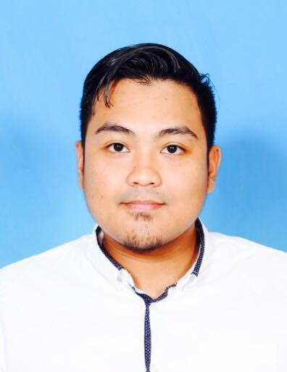

Competent and dependable fresh Data Communication graduate with a solid fundamental skills and knowledge on telecommunication and networking technologies who seeks for technical and engineering position.

**BA. OF ENGINEERING TECHNOLOGY IN DATA COMMUNICATION**

**MOHAMMAD AMIRUL SYAFIQ**